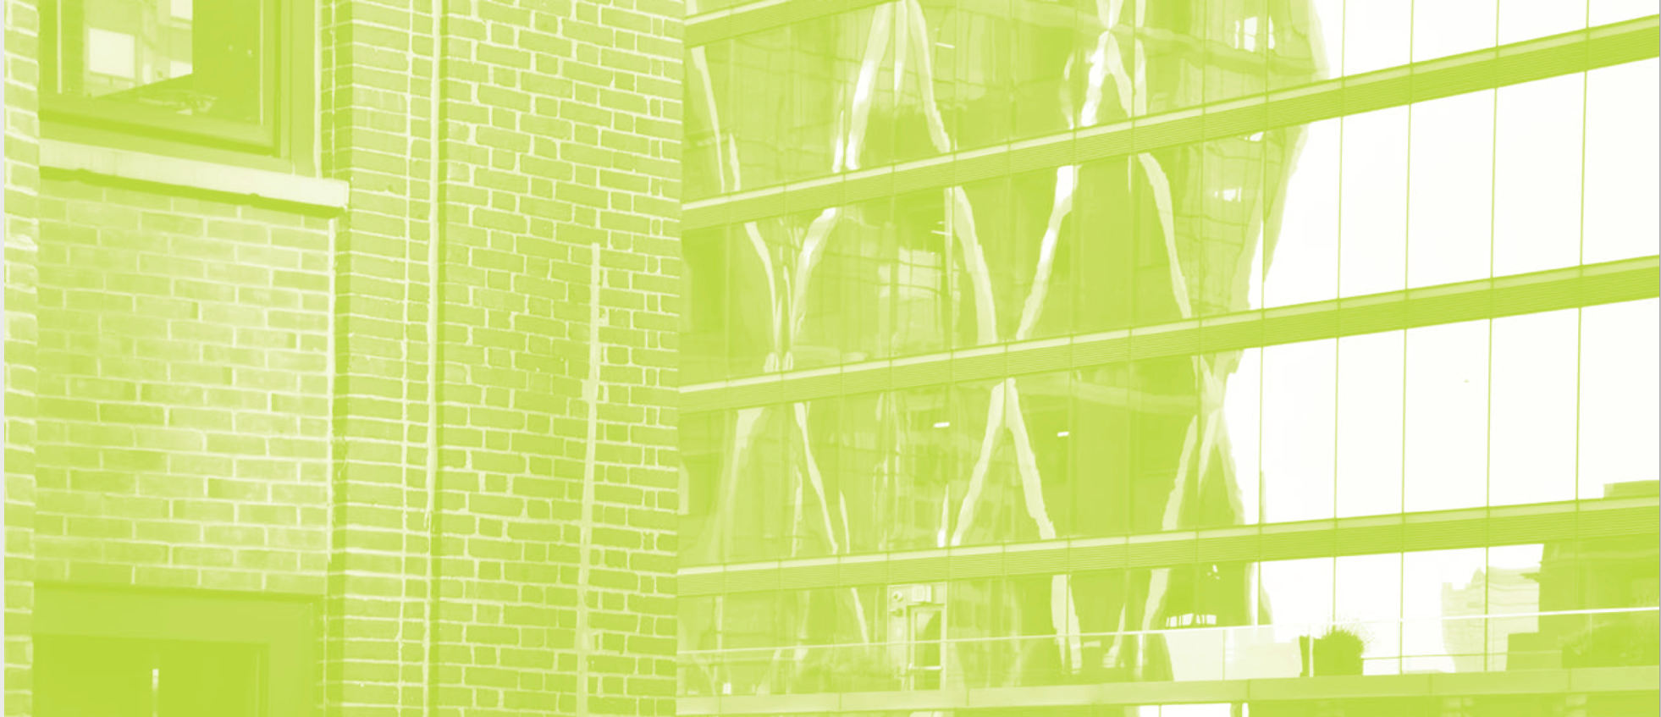

GREEN PROFESSIONAL BUILDING SKILLS TRAINING
"Everyone should take this course, even if it's not directly related to their job, because this information is important! It helps to be informed about the future of our planet."
— Fundamentals of Building Green Student, 2018
GPRO is a certificate program that teaches the people who build, renovate, and maintain buildings the tools to integrate high-performance construction and maintenance practices into their everyday work. Our holistic approach to sustainability training—combined with expert advice and the latest adult learning techniques—have made GPRO an education trailblazer for building trades and operators across the country.

Join over 14,600 certificate holders in more than 70 U.S. and Canadian cities—get ahead of the curve!

WHY GPRO?

- Qualify for LEED Pilot Credit 81
- Gain industry buy-in from major industry stakeholders
- Join the rapidly growing green building industry
- Lead the way to sustainability through building and construction trades
- Reap the long-term benefits of energy savings and improved building performance
- Customize content with instructors focused on issues significant for your trade

COURSES OFFERED

Course Name | Course Length | Continuing Education Credits
Fundamentals of Building Green | 4-6 hours | 4 AIA and GBCI CE Credits
Operations & Maintenance Essentials | 12 hours | 12 AIA, GBCI and PDH CE Credits
Mechanical | 12 hours | 12 AIA and GBCI CE Credits
Electrical Systems | 10 hours | 10 AIA and GBCI CE Credits
Plumbing | 10 hours | 10 AIA and GBCI CE Credits
Construction Management | 10 hours | 10 AIA and GBCI CE Credits

CONTACT INFORMATION

To learn more about GPRO, visit our website at gpro.org. For questions or to schedule a class, contact us at gpro@urbangreencouncil.org or 212-514-9385 ext. 126

